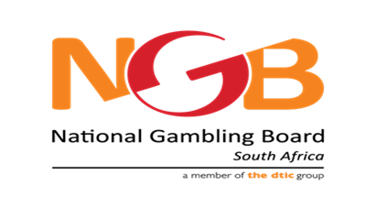
NATIONAL GAMBLING BOARD
1085 Francis Baard Street,
Hatfield,
Pretoria,
0028

APPLICATION FORM: NGB ENTERPRISE DEVELOPMENT PROGRAMME

- CONTACT INFORMATION OF PRINCIPAL APPLICANT

Last Name* First Name*

Email*

Business Telephone number Mobile Phone number*

ID number*

Home language* Race* Gender* Citizenship*

Business Street Address (Personal street address if business has not been registered yet)*

City*

Postal code*

- ABOUT YOUR BUSINESS OR BUSINESS IDEA (20 POINTS)

Company Name (Future Name or state “not yet registered) Submit proof of registration (registration documents)*

Website URL

Year Started (e.g. 2002 or 0000 if not yet registered)* Type of Company*

At what stage of development is your company?* Industry*

B-BBEE Level (Submit a B-BBEE certificate or sworn affidavit)*

Percentage of black ownership*

Number of employees (0 is business idea stage)*

Approximate Gross Annual Revenue*

- MARKET AND MARKET POSITIONING (80 POINTS)

Please provide a brief description of your business or business idea.*

What particular problem or market gap will your goods and/or services be addressing?*

Do similar goods and/or services already exist (locally or globally)? Briefly explain.*

List your five main competitors.*

What is your competitive advantage?*

Describe your target market – corporate or individual, including a description of the typical profile of your customer.*

What is the size/potential size of your target market? Describe how you have calculated/estimated this figure.*

How do you/will you generate revenue?*

How do you currently or plan to promote and sell your goods and/or services?*

List your top 3 Strengths, Weaknesses, Opportunities, and Threats involved in your business or business idea.*
Strengths: characteristics of the business or project team that give it an advantage over others.
Weaknesses (or Limitations): are characteristics that place the business or team at a disadvantage relative to others.
Opportunities: external chances to improve performance (e.g. make greater profits) in the environment.
Threats: external elements in the environment that could cause trouble for the business or project.

- ABOUT YOUR TEAM

What management/technical team do you have supporting your business/business idea, goods and / or service?*

